**Transformer- Part-1: English-to-Arabic translation**

1. **Model Overview (GPT-2)**

The core of this setup is the GPT-2 model, which is a Transformer-based language model designed primarily for text generation tasks. However, when fine-tuned on parallel datasets (like English-Arabic sentence pairs), it can be adapted for translation tasks.

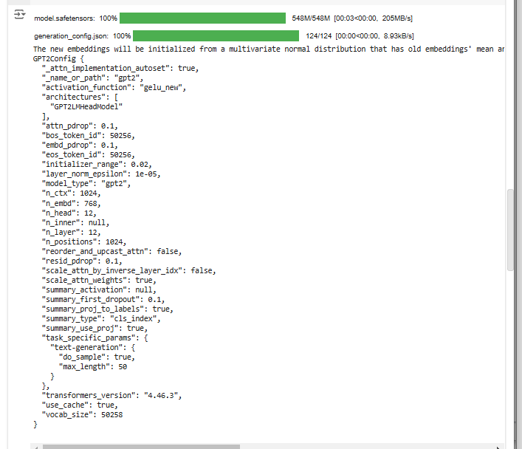

**Key Characteristics of GPT-2:**

* Transformer Architecture: GPT-2 uses the Transformer architecture, specifically the decoder-only setup, where it processes sequences in a unidirectional manner (from left to right).
* Self-Attention Mechanism: This mechanism enables the model to consider relationships between all words in a sentence, regardless of distance, which is crucial for tasks like translation where the meaning of words can depend on context.
* Pre-trained Model: GPT-2 has been pre-trained on vast amounts of text data, making it capable of generating coherent text based on context. However, it needs fine-tuning for specific tasks like translation.
* Output Generation: The model predicts the next token (word or subword) in a sequence, and through a process of sampling and ranking, it generates the translated text.

**Model Configuration:**

Key configurations of the GPT-2 model for translation tasks include:

* Activation Function: GELU (Gaussian Error Linear Unit) is used, which helps the model learn more efficiently during training.
* Layer Setup: The model includes 12 layers of self-attention heads and has a hidden size of 768. This makes it capable of understanding complex linguistic patterns.
* Vocabulary Size: The model has a vocabulary of 50,258 tokens, covering a wide range of linguistic nuances.
* Context Window: GPT-2 processes sequences of up to 1024 tokens, meaning it can handle moderately long sentences.

**2. Training Process:**

The training process involves fine-tuning the GPT-2 model on English-Arabic translation pairs. The model learns to generate Arabic translations given English input during each training cycle.

**Training Details:**

* **Epochs**: The model is trained for 10 epochs, during which the model’s parameters are adjusted to minimize the error between predicted translations and actual translations.
* **Losses**: During training, both **training loss** and **validation loss** are tracked. These losses help monitor the model’s learning progress.

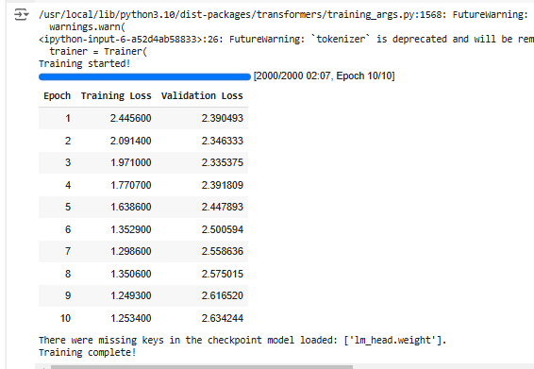

* **Training Loss**: The decrease in training loss across epochs suggests that the model is gradually learning the translation task.
* **Validation Loss**: Although the training loss decreases steadily, the validation loss fluctuates. This could indicate potential **overfitting**, where the model performs well on the training data but struggles to generalize to unseen data.

**3. Translation Outputs:**

After training, the model is used to generate translations for various English sentences into Arabic. However, some of the translations appear nonsensical, indicating that the model's training was not fully successful.

**Example Translations:**

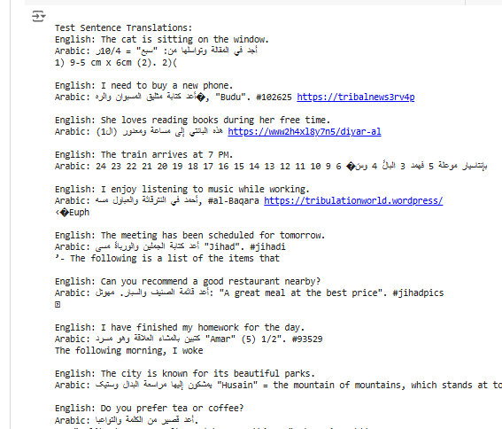

These translations do not make much sense, likely due to:

1. **Overfitting**: The model might have learned too much from the specific training data, losing its ability to generalize.
2. **Data Quality**: The quality or correctness of the training data could have been compromised, leading the model to produce incorrect outputs.
3. **Insufficient Training**: The model may not have been exposed to enough data or training epochs to generate fluent translations.

**4. Evaluation Metrics:**

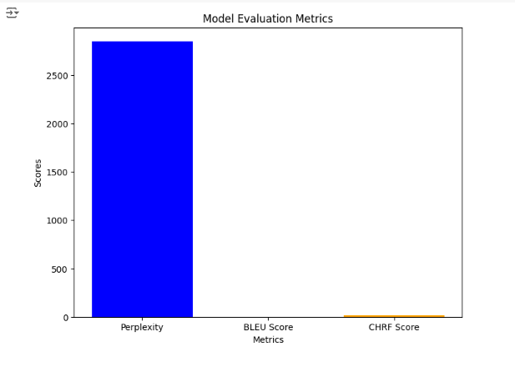

* Perplexity: The model has a perplexity score of 2849.448. A lower perplexity score is preferred, as it indicates that the model is better at predicting the next token in a sequence. A high perplexity indicates poor prediction quality.
* BLEU Score: The BLEU score is 0, which is the worst possible score. BLEU measures how well the model’s output matches the reference translation. A score of 0 means the translations are far from correct.
* CHRF Score: The CHRF score is 16.0. This score is based on character-level n-grams and is used to evaluate machine translation. A higher CHRF score indicates better translation quality, but a score of 16 is relatively low, suggesting that the model's translations are still inaccurate.

**5. Challenges and Limitations:**

* Overfitting: The fluctuations in validation loss suggest that the model might have memorized the training data too well, preventing it from generalizing to new examples.
* Training Time: More training epochs or larger, more diverse datasets could improve the model's ability to generate accurate translations.
* Arabic-Specific Issues: Arabic is a complex language with various forms and structures, which can make translation challenging, especially when working with a model not specifically designed for translation tasks.

**Conclusion:**

The GPT-2 model, though pre-trained on a large corpus, struggles to perform well on English-to-Arabic translation after fine-tuning. The translation quality is subpar, as evidenced by the low BLEU score and high perplexity. Addressing the overfitting issue, improving the training data, and training the model for more epochs could help in enhancing its translation abilities. Additionally, exploring other models specifically designed for translation tasks, such as MarianMT or T5, might provide better results for this task.