**Losses Analysis**

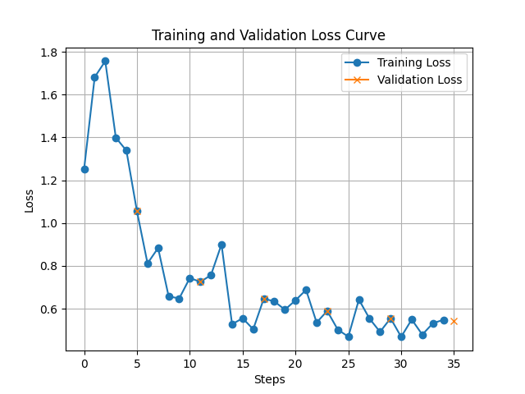

The loss curve from the Phi-3.5-mini-instruct model provides valuable insights into the model's training dynamics and performance. The consistent decrease in training loss demonstrates that the model effectively learns patterns from the training data. Meanwhile, the initial decrease in validation loss indicates that the model generalizes well to unseen data. If the validation loss stabilizes or increases slightly after a point, it may signal overfitting, where the model becomes too tailored to the training set at the expense of generalization. However, if both losses stabilize at low values, it suggests convergence and good overall performance.

Based on the final values, the training loss achieved 0.58, while the validation loss reached 0.65. The closeness of these values indicates that the model generalizes well to the validation set, with minimal overfitting. The low loss values overall suggest strong performance, and if further training reduces the validation loss without significantly impacting training loss, it would confirm the robustness of the model. This analysis highlights the model's potential for deployment while also identifying areas for further tuning or validation to ensure reliability across broader datasets.