LSTM TRAINING CURVE:

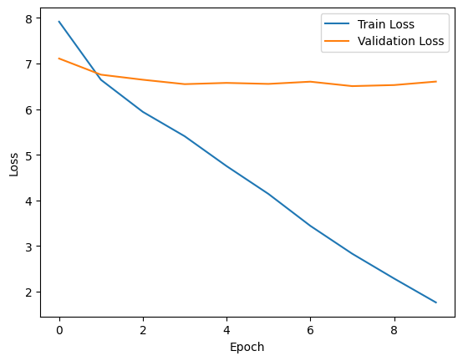

The training data is indicated by the graph's training loss (blue curve), which steadily decreases over the epochs. In the early epochs, the validation loss (orange curve) shows good generalization to unseen data, first decreasing. But the training loss keeps decreasing while the validation loss reaches a plateau and slightly rises around the fifth epoch. The difference indicates that the model is starting to overfit, becoming too focused on the training set and losing its capacity for generalization.

SEQ 2 SEQ TRAINING CURVE:

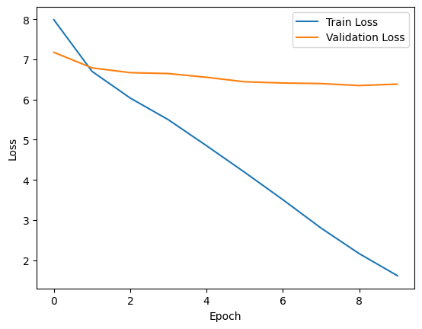

The training loss and validation loss trend over several epochs. Indicating that the model is learning and getting better at using the training data, the train loss begins at about 7.7 and gradually drops over the epochs. The model appears to be generalizing well to the validation data, as evidenced by the validation loss, which initially drops more quickly than the train loss and starts at a slightly higher value of about 8.1. The model may be beginning to overfit the training data and not generalize as well to the validation data, though, as the validation loss begins to rise after the fourth epoch while the train loss keeps declining. This trend